Naughton REU Application
SUMMER INTERNSHIP OFFER OF TRAINING FORM SUMMER 2022

Proposer details:
Title: | Ussher Assistant Professor in Ultramicroscopy
Name: | Dr Lewys Jones (he/him)
Email: | lewys.jones@tcd.ie
Website: | https://www.tcd.ie/Physics/research/groups/ultramicroscopy/
If your grade does not allow you to supervise students, please supply the name of support PI: | Not applicable.

Student required:
Specify any previous training / experience the student should have:
We would welcome a student with experience in Physics, Electrical Engineering, or a similar technical or engineering background. Expertise in basic data capture and analysis (e.g. Excel) would be a bonus but not essential.
Study level (3rd year, 4th year) | 3rd or 4th year student preferable, however a 2nd year with specialised experience in energy use monitoring or renewable energy would be acceptable.
Any other requirements: | The Ultramicroscopy Research Group is committed to encouraging engagement with communities currently underrepresented in STEM. Applicants from all backgrounds are encouraged to apply.

Traineeship offered:
Brief job description: (please include (1) type of work, (2) what student should hope to achieve at end of the process, (3) who will supervise student on daily basis (post-doc etc.))
The Ultramicroscopy Research Group is seeking a student to conduct a pilot study assessing the energy consumption of large infrastructure in the Advanced Microscopy Laboratory. Many small devices (such as home appliances) indicate their energy use and efficiency with clear labelling. However, large research infrastructure is often overlooked in this regard. Without accurate assessment of the energy footprint, we cannot hope to improve this.

In this pilot study, we are aiming to measure the operating energy use of our facilities large infrastructure. This incudes scanning electron microscopes, transmission electron microscopes and various supporting compressors and chillers. This is thought to be on the scale of at least several tens of kilowatts. The student will measure electrical loads at various points, measure air flow rates, and record thermal images (such as the one shown here) to identify energy-hungry infrastructure.
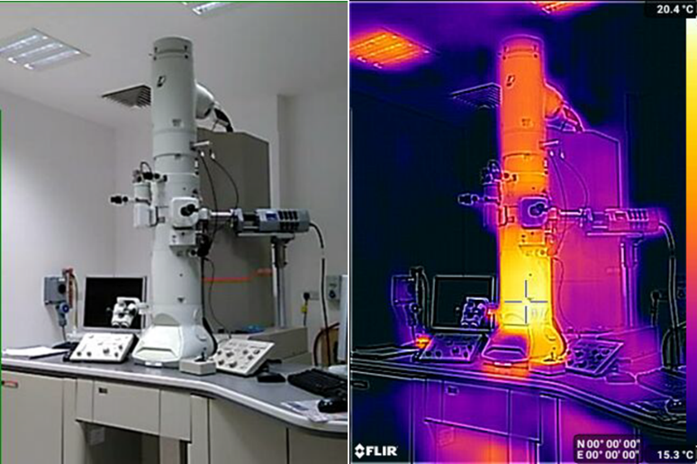
If things progress well, as a stretch goal, we will try to include other instruments such as NMR, XRD, XRF or MRI machines in the wider university campus.

We also want to understand more about the embodied energy in the infrastructure itself and want to asses, for example, the energy used to produce the liquid nitrogen or the compressed air we use.

The successful conclusion of the project will see the creation of a tool for others to follow (most likely a guided spreadsheet), where people can follow our method to asses their own instruments. This, combined with the information form our facility booking system, will allow us to understand the carbon-footprint per hour of imaging time. From this, we hope to be able to inform policies around reducing the energy use or towards suitable carbon offsetting. Both of these goals are impossible at present without the data collection proposed here.

The Advanced Microscopy Laboratory in Trinity College Dublin is one of the largest imaging centres in Ireland. The student will benefit from the expertise of the on-site technical and support staff, but will also be directly assisted by a post-doc from the Ultramicroscopy Research group. Regular team meetings with the group leader (Prof. Jones) will further support and guide the project.
Link to research group or supervisor webpage: | https://www.tcd.ie/Physics/research/groups/ultramicroscopy/
Location of lab: | The Ultramicroscopy Research Group is based at the Advanced Microscopy Laboratory (https://www.tcd.ie/crann/aml/). This is a short walk from the main Trinity campus.

Working hours:
Number of Weeks offered: | 10-14 weeks ideally, but can be flexible to suit student holiday/travel needs.
Hours per week: | Typically 35h per week.
Earliest Start Date possible: | April 25th
Latest End Date possible: | August 26th

