Dublin City University (Ireland) Project for Visiting Notre Dame Students 2022
Professor Silvia Giordani
School of Chemical Sciences, Dublin City University, Glasnevin, Dublin 9, Ireland
Email: silvia.giordani@dcu.ie
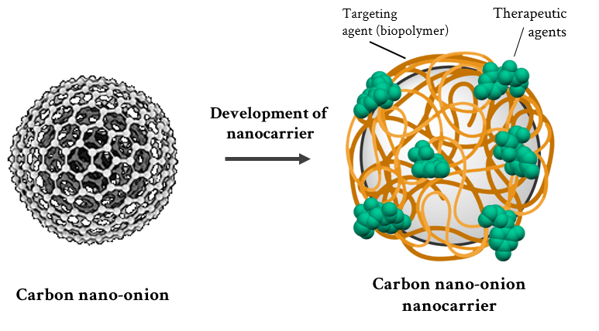
Graphene, fullerenes and carbon nanotubes are well-known members of the carbon nanomaterial family. This family also includes a unique material—termed the carbon nano-onion [1]. Carbon nano-onions are multi-layered fullerenes, spherical nanoparticles that have a multi-layered structure of graphitic carbon. Beyond their morphology, carbon nano-onions are also known for their biocompatibility, ease of surface modification, and their small size. Due to the above mentioned favourable properties, carbon nano-onions have been investigated for their biological applications. These investigations included biocompatibility studies of carbon nano-onions (in vitro, in vivo, ex vivo), their use for sensing, their ability to be internalised by cells, their cellular internalisation pathways, their cellular colocalisation, and the use of carbon nano-onions as drug delivery systems for the targeted delivery of anticancer therapeutics [2], which is the topic of this proposed research project.
The project aims to develop a drug delivery system designed to deliver an anticancer therapeutic to cancer cells in a targeted manner. Carbon nano-onions will be used as the scaffold for this nanocarrier [3] system. The spherical surface of carbon nano-onions will be decorated with the targeting agent, the fluorophore and the anticancer drug payload. In brief, this project will involve:
- The surface functionalisation (covalent and non-covalent) of carbon nano-onions with a targeting agent, a fluorophore and an anticancer drug
- The physico-chemical characterisation of the nanocarrier system
In this project, the student will gain an appreciation of carbon nanomaterials and their chemistry. The student will develop their lab skills and gain experience working with and functionalising carbon nanomaterials. Moreover, the student will have the opportunity to work with various characterisation techniques, including absorption and emission spectroscopies, dynamic light scattering (DLS) and zeta potential.
[1] Bartelmess, J. & Giordani, S. Carbon nano-onions (multi-layer fullerenes): chemistry and applications. Beilstein J. Nanotechnol. 5, 1980–1998 (2014).
[2] Bartkowski, M. & Giordani, S. Carbon nano-onions as potential nanocarriers for drug delivery. Dalton Trans. 50, 2300–2309 (2021).
[3] Peer, D. et al. Nanocarriers as an emerging platform for cancer therapy. Nature Nanotech 2, 751–760 (2007)

